U30 operating instruction
Alfawise

目录
A. Product information 3
(1) Model parameter 3
(2) Machine introduction 5
(3) Nozzle module exploded view 5
(4) Machine assembly 6
1. Gantry installation 7
2. X-axis installation 8
3. Mounting the x-axis beam 11
4. Install the gantry upper beam 11
5. Mounting screw 11
6.Install Teflon tube 12
7.Install the z-axis limit switch 13
8.Mounting aluminum substrate 13
9.Wiring 14
10. Screen wiring 14
11.Mounting rack and glass 16
12 .Assembly completed 16
（5） Power regulation 17
（6）leveling method 18
B． Machine operation 19
（1）Machine control 19
（2）Main interface 20
C． Cura installation and operation software 21
（1） Slice software offline printing instructions 24
（2）Software parameter setting 27
D． Operation for online printing 30
E． Resume printing and filament run-out detection function 33
（1）Power outage recovery 33
（2）Filament run-out detection 33
F． FAQ manual 35
Question1: How to update the firmware? 35
Question 2:What if the filament does not discharge from the machine? 35
Question 3: When the machine returns the filament, it can't be returned. What should I do when stuck in the pneumatic joint? 36
Question 4: What should I do if I cannot resume printing after power shutdown? 36
Question 5: When the machine is leveling, the nozzle moves to the left, it can be leveled normally. When the nozzle moves to the right, it is found that the distance between the nozzle and the heated bed are very far or very close. If the spring is adjusted to the extreme position, it still cannot be leveled. What should I do? 37
Question 6: 38

Safety Precautions
1) The temperature of the nozzle parts can reach 250 °C during the operation of the machine. To ensure your safety, it is forbidden to touch the model and nozzle directly with your hand while the printer is printing or cooling.
2) During the operation of the machine, it is forbidden to reach into the machine to prevent pinching.
3) The working voltage is 110~220V AC voltage 50HZ AC. The three-pin socket must be grounded. Do not use other power sources to avoid damage to components or fire, electric shock and other accidents.
Note: Before powering on, please check whether the input voltage value of the switching power supply meets the voltage standard of the country or region.
4) When the machine is working continuously for ≥ 96 hours, it should be stopped for 1-3 hours.
Consumables
The consumables are not used after unpacking or for a long period of time after the print model is completed. The consumables should be taken out of the printer and sealed to prevent the consumables from being exposed to the air for a long time, causing moisture and affecting the print quality. At the same time, when the consumables are removed The front end of the consumable should be fixed on the tray to avoid consumables and affect the next print.
To use this printer, it is recommended to use the supplies provided by the company. At present, the quality of consumables sold in the retail market is uneven, and printing is prone to breakage.
Staggering and clogging the printer nozzle, etc., and irreversible damage to the heating components of the nozzle, the extrusion motor and the extrusion gear. The company will not guarantee the printer due to the use of consumables other than our company.
Environmental requirements
Temperature requirement: 10°C~30°C, humidity requirement: 20%~50%, this 3D printer can work normally within this range; beyond this range, this 3D printer will unable to achieve the best print results.

Product information

Model parameter
model | U30 | Machine size | 402*382*655mm
frame | Classic aluminum frame | Machine weight | 7.8KG
Molding | FDM (hot melt production) | Package dimensions | 467*412*187mm
Number of nozzles | 1 | Consumable color | Multi-color optional
Molding size | 220*220*250mm | Power requirement | Output 24V
Layer thickness | 0.1-0.4mm | operating system | Windows,Linux,MAC
Memory card offline printing | Support TF card | Interface language | English
LCD screen | YES | Environmental requirements | Temperature 10-30 ° C  Humidity 20-50%
printing speed | Not more than 120mm/s | Nozzle temperature | Room temperature to 250 ° C
Nozzle diameter | 0.4mm | Hot bed | 3mm thick integrated heating aluminum plate, forming platform
Slicing software | Cura,repetier-host | Support consumables | PLA, ABS, wood, copper consumables
file format | STL,G-Code,OBJ | Consumable diameter | 1.75mm

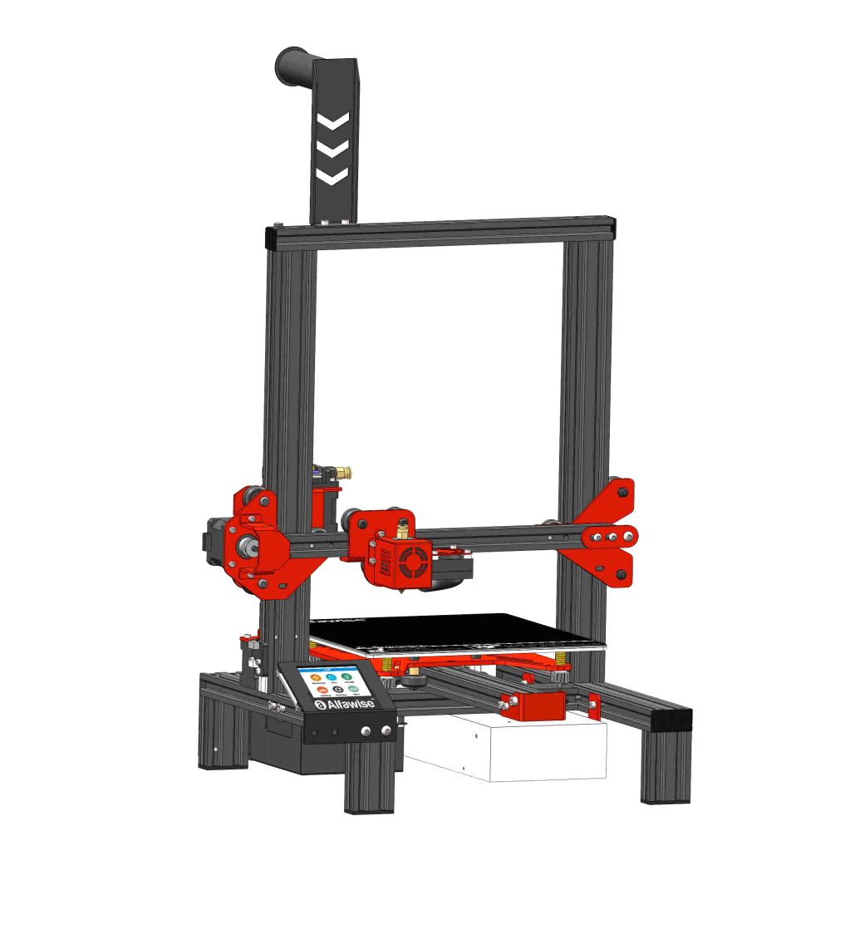
Machine introduction
Gantry
Rack

Extruder module

Nozzle module

Hot bed

Motherboard
Foot

power supply

Nozzle module exploded view

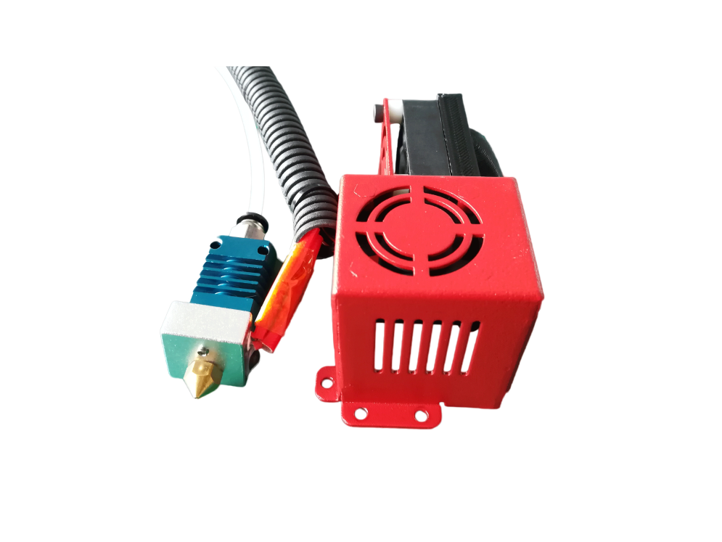
4010 fan

Air guide

3010 fan
Quick pneumatic joint

Heat sink
Sheet metal protective case
Heating block

nozzle

Heater
Thermistor

Machine assembly

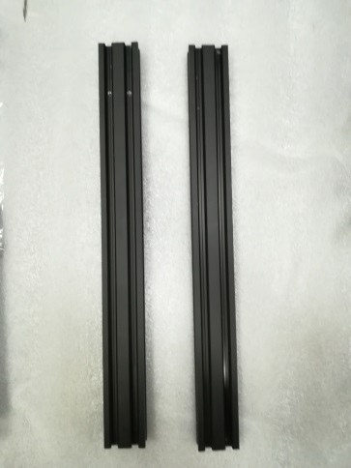
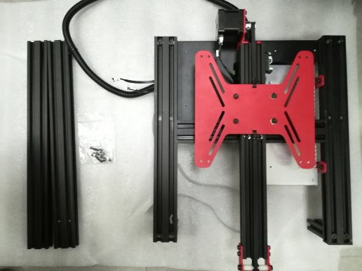
1. Gantry installation

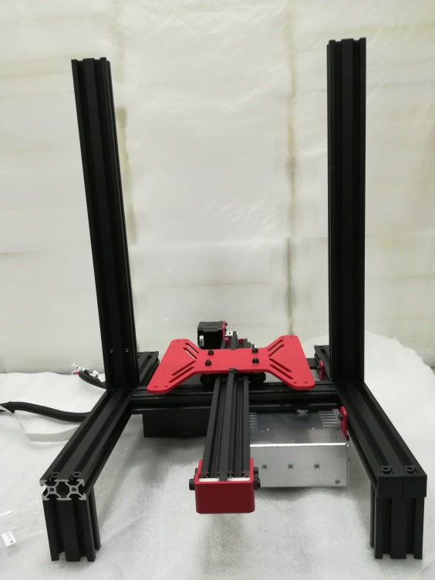

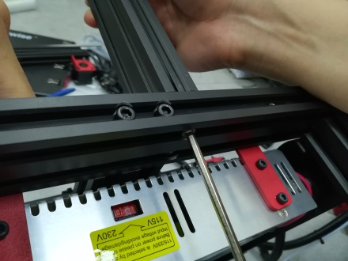
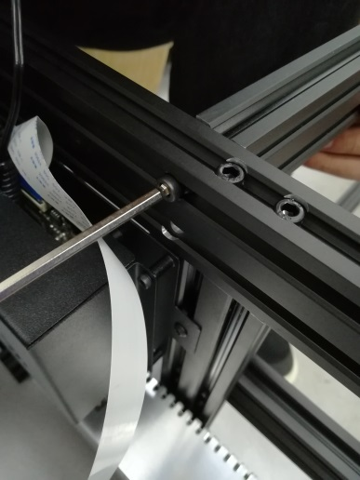

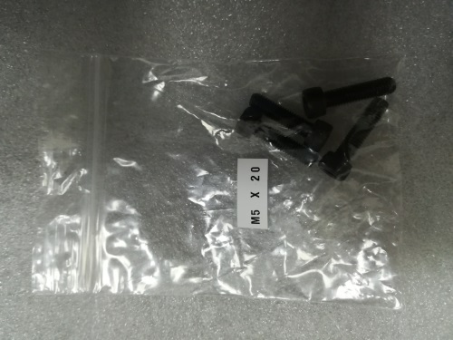

Two blue boxes in the picture, need to be in one direction
Two threaded holes to be on the side of the Y-axis motor

The screw used is M5*20

2. X-axis installation
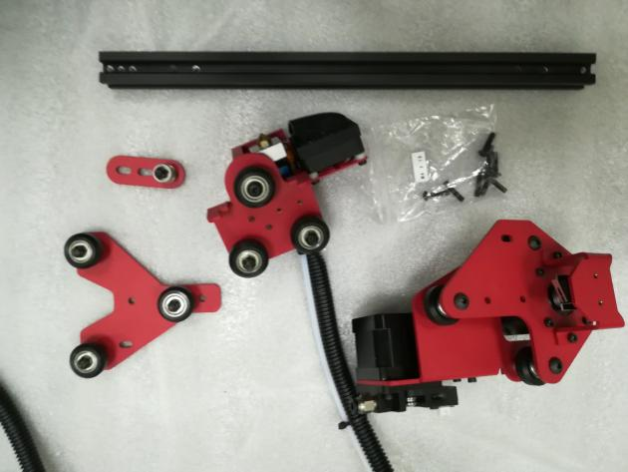
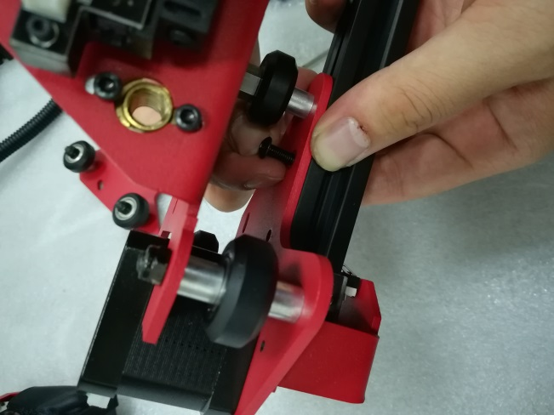

Screws are all M4*16
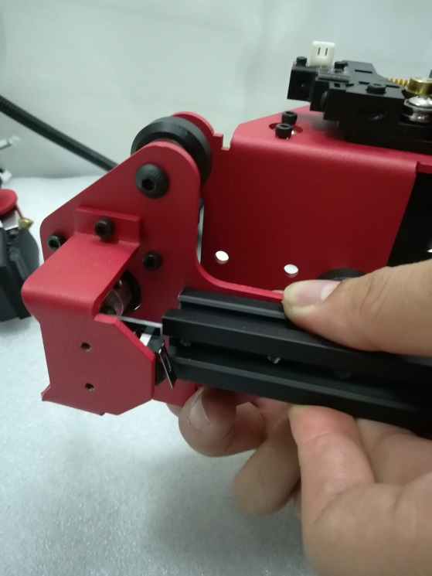

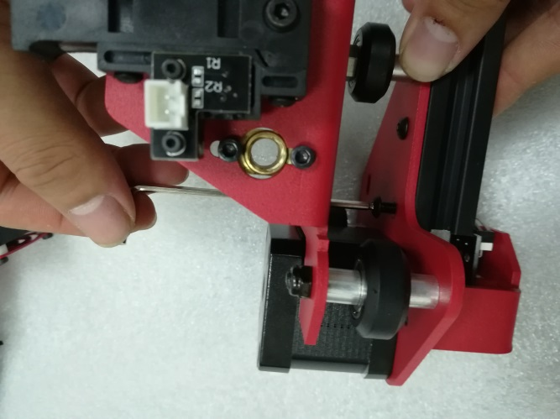

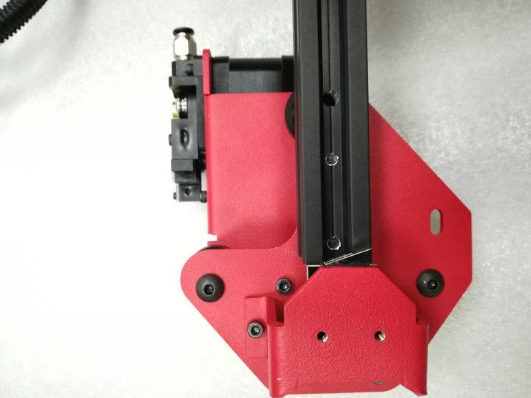
If the nozzle block wheel cannot enter, use a wrench to adjust the eccentric nut.

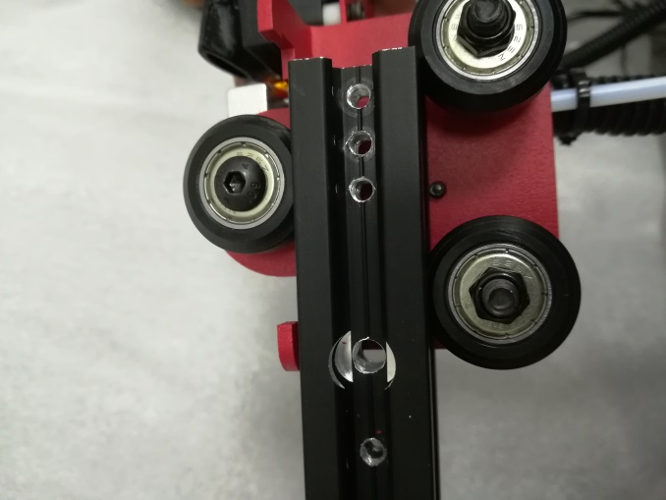

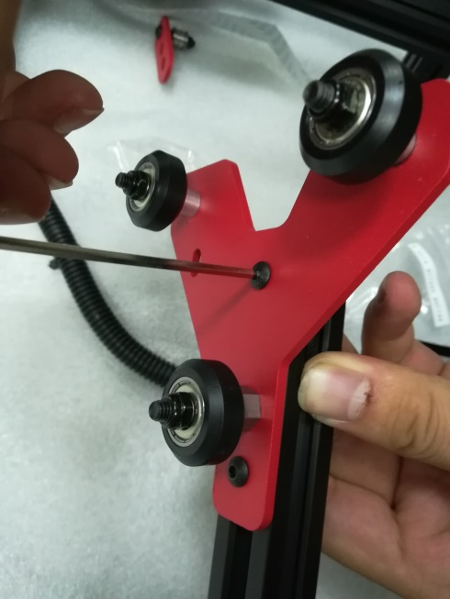
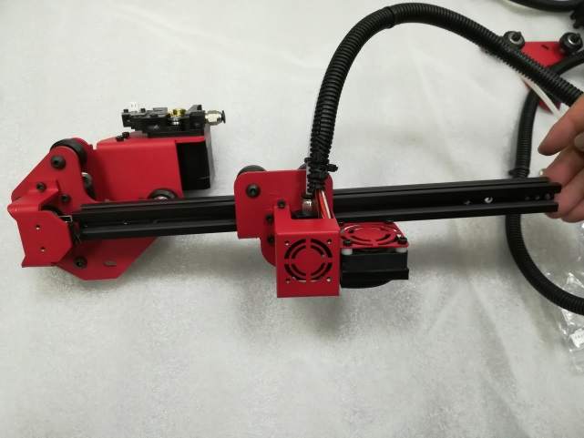

Box side up
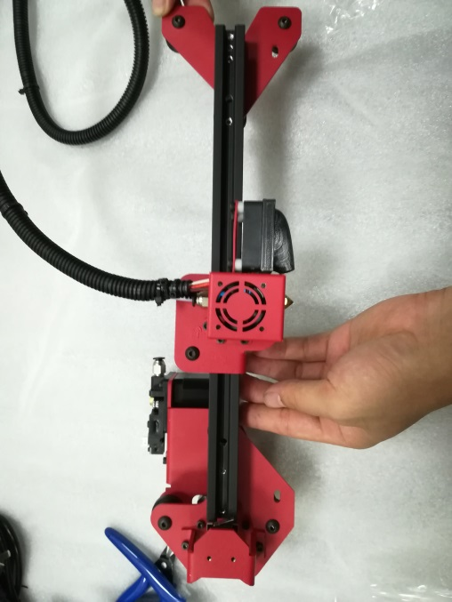
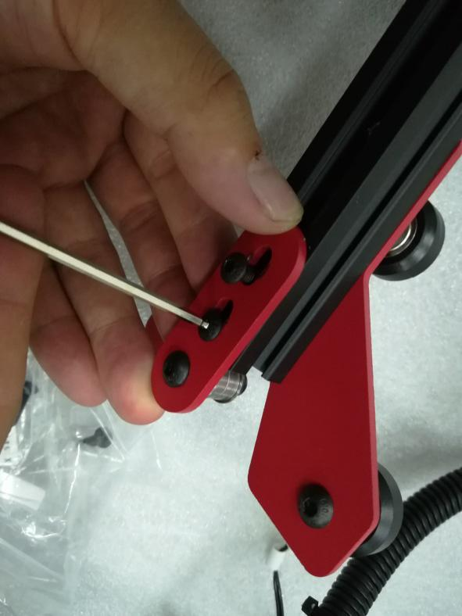

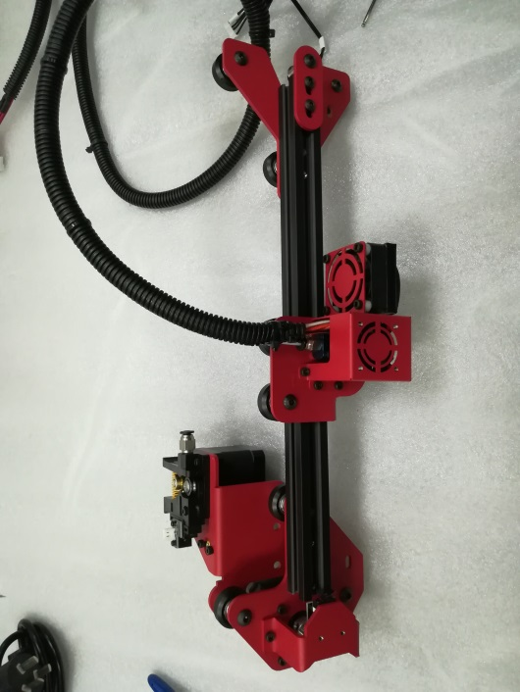

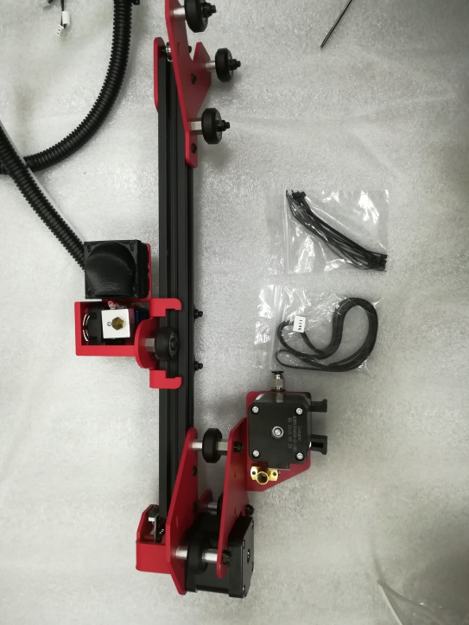

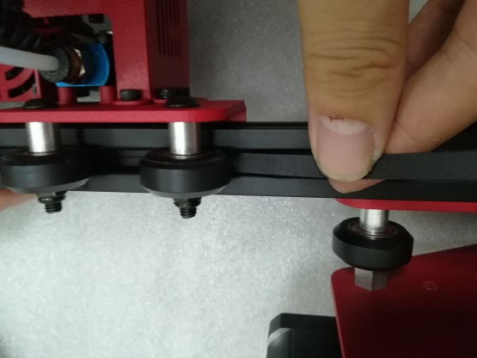

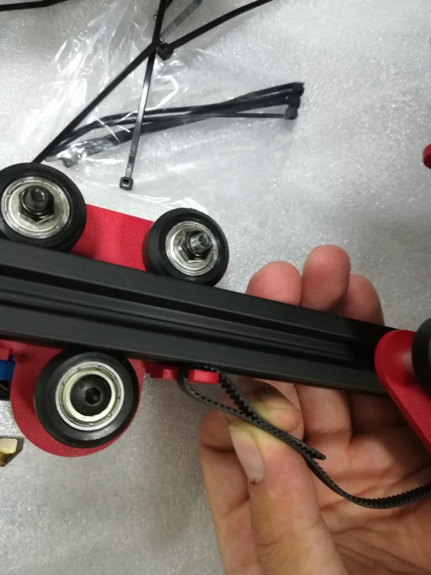
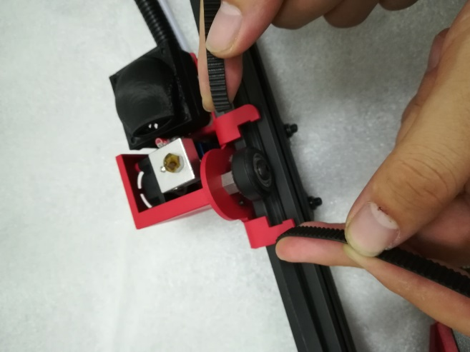

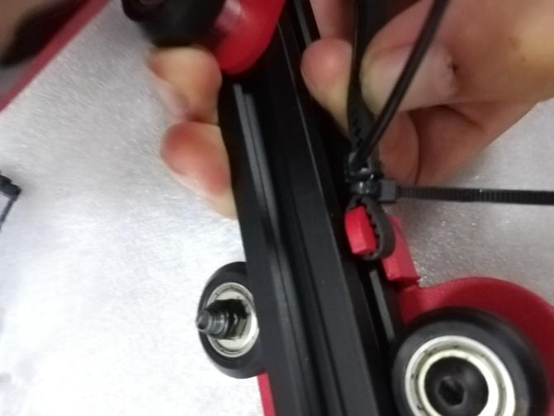

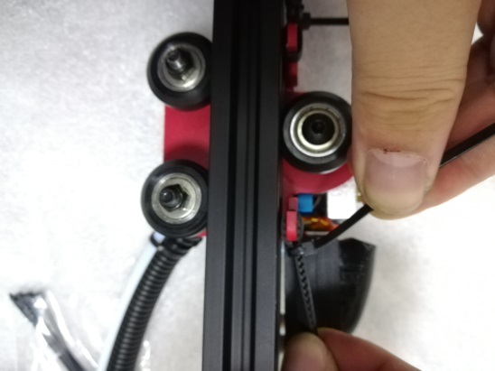

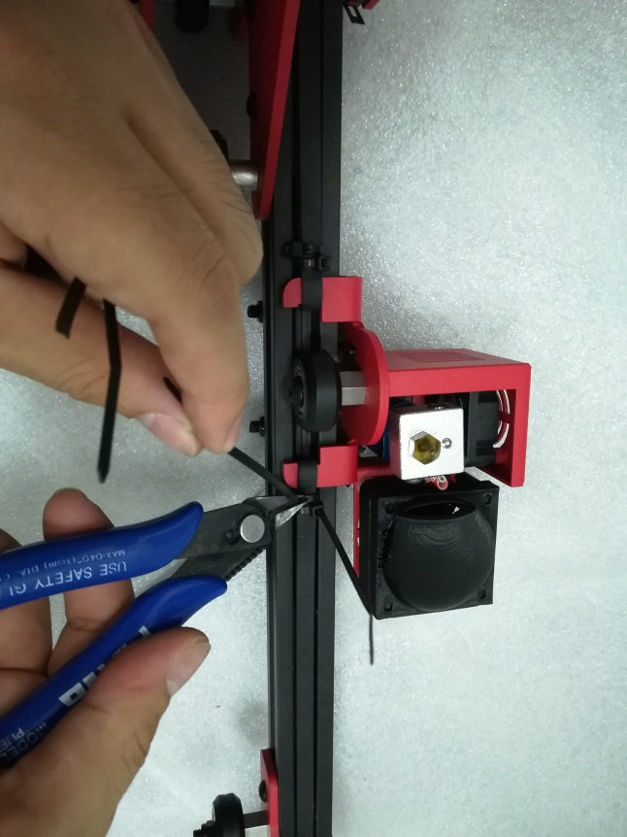

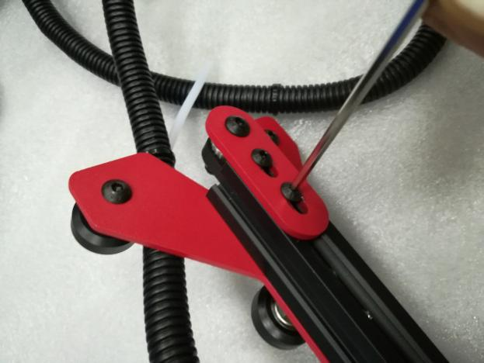

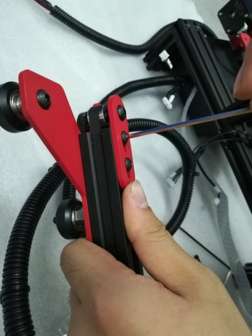

The tension of the belt can be adjusted by the two screws on the box

3. Mounting the x-axis beam
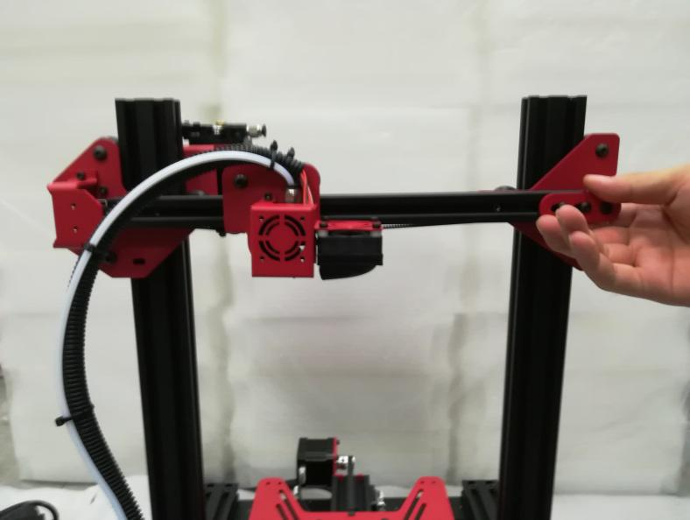
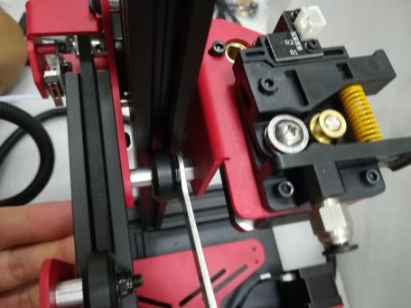

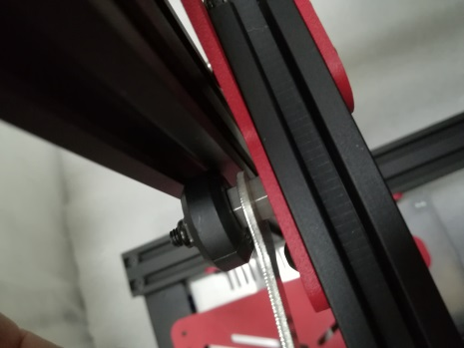

If the wheel does not fit in, you can adjust the wheel with the eccentric nuts on both sides. Let the X-axis beam enter

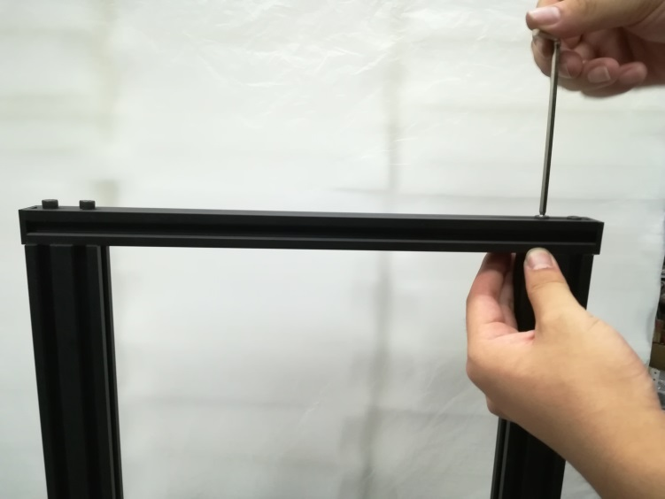
4. Install the gantry upper beam
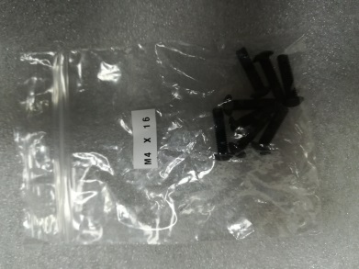

Use 4 M5*20

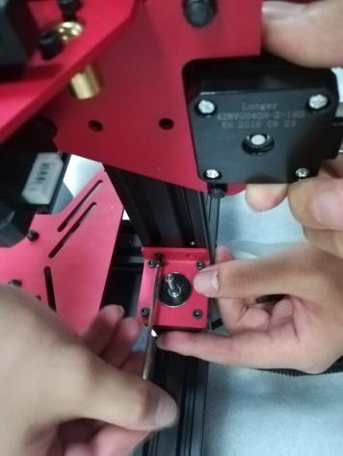
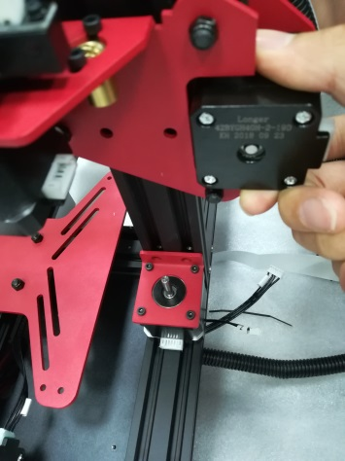
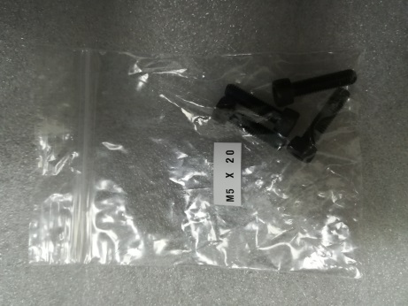
5. Mounting screw

Use 2 M4*16
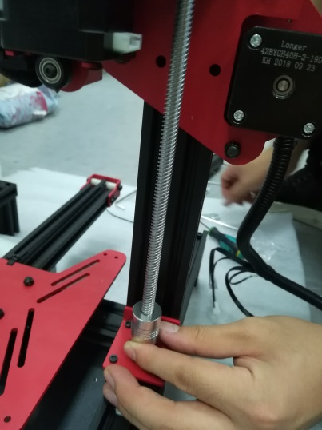
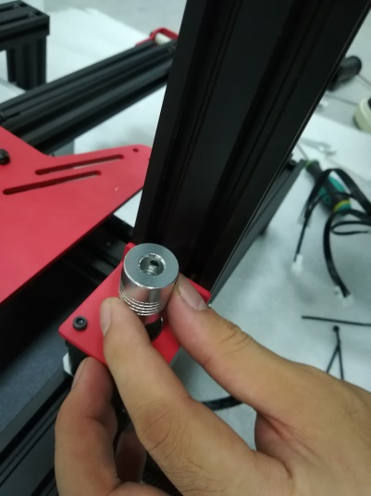
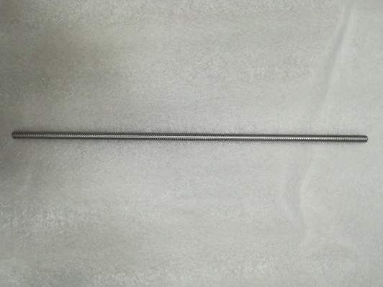

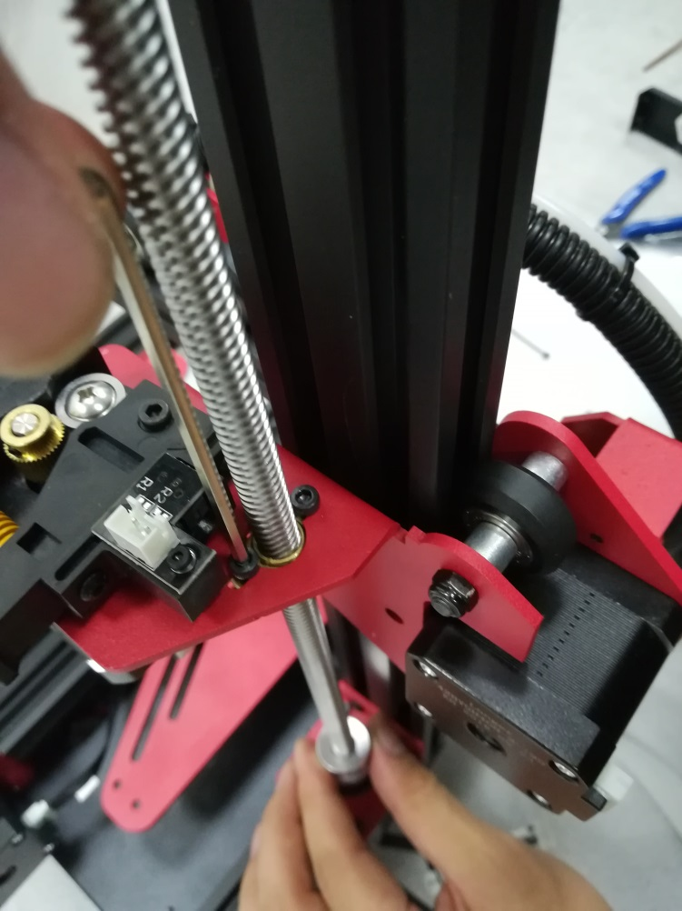
Let the lead screw snap into the coupling and the motor shaft is also aligned with the lead screw. Tighten the top wire

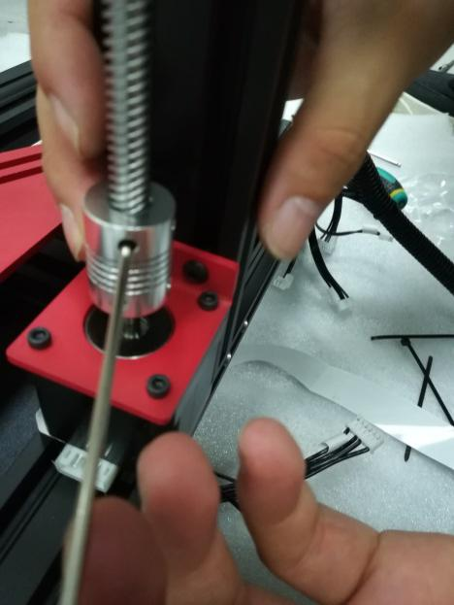

Adjust the screw movement by adjusting these two screws. The two screws cannot be tightened too tightly. Turn the coupling by hand to adjust the movement of the lead screw.

6.Install Teflon tube
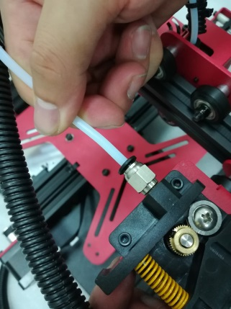
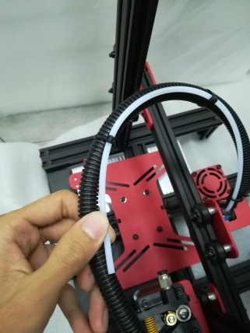
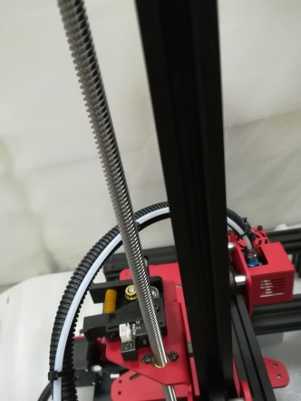

note
Teflon tube and line direction

7.Install the z-axis limit switch
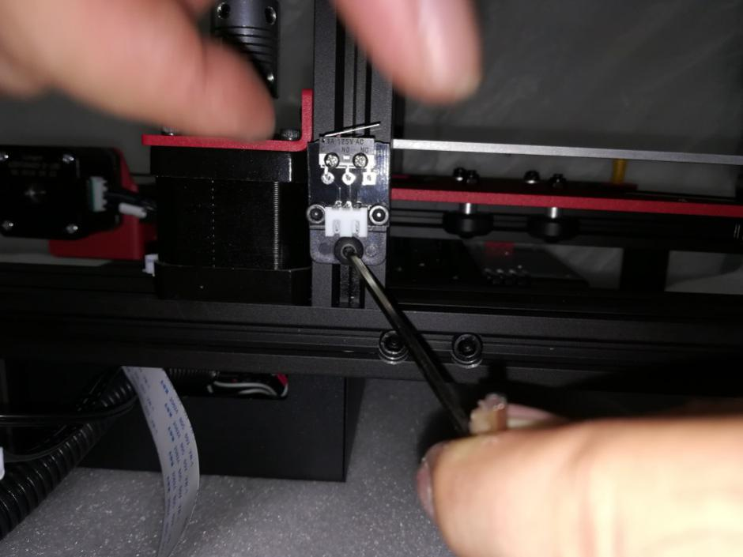

Z-axis limit opening installation is about 15mm from the base (this is adjustable)

8.Mounting aluminum substrate
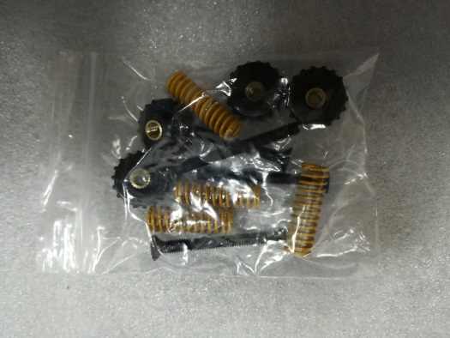
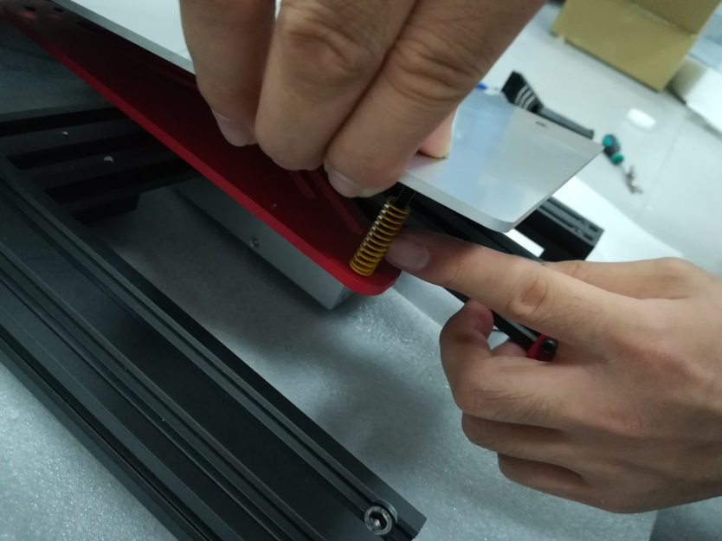

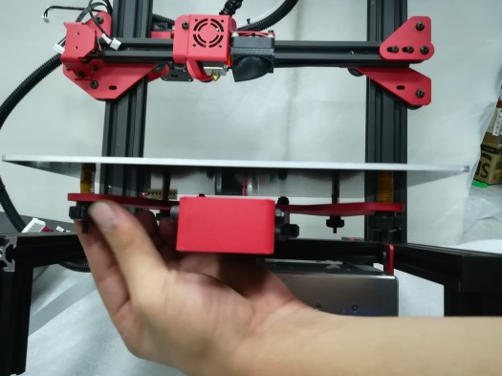

9.Wiring

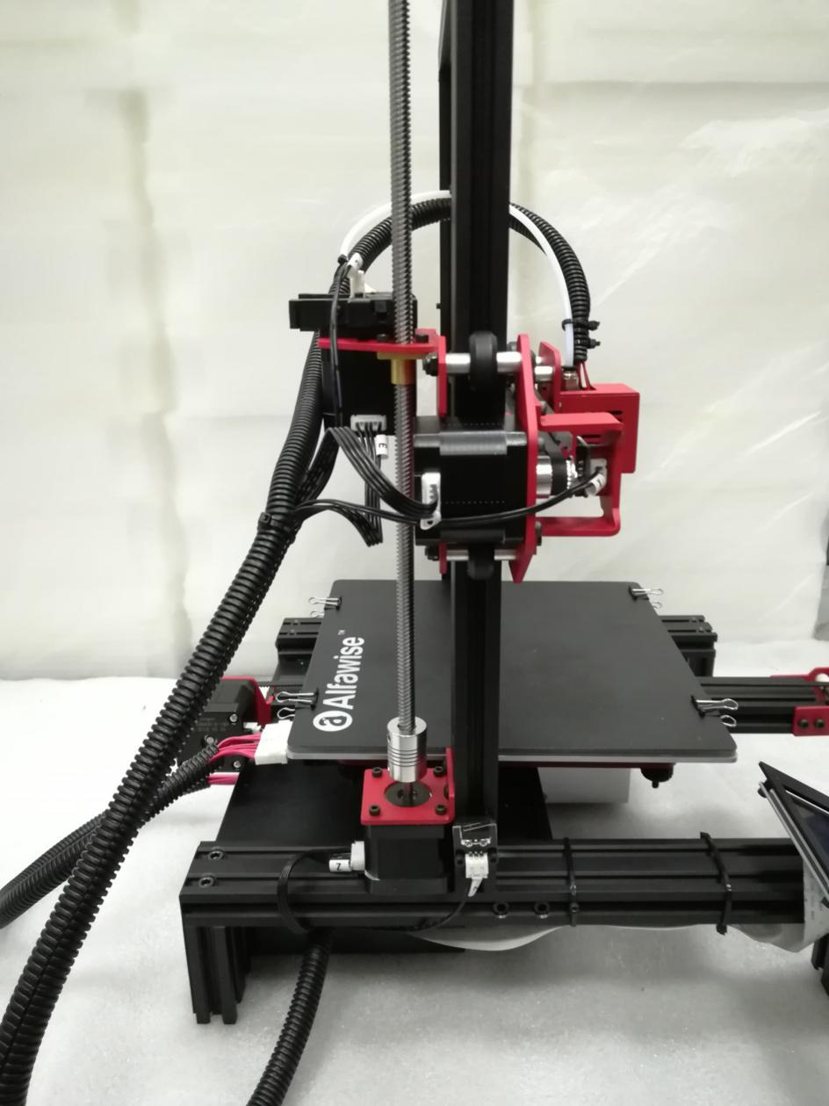

4

3

2
1

6
5

1. X motor line 2. X limit switch line 3. E-axis motor line
4. E-axis break detection 5. Z-axis motor line 6.Z-axis limit switch

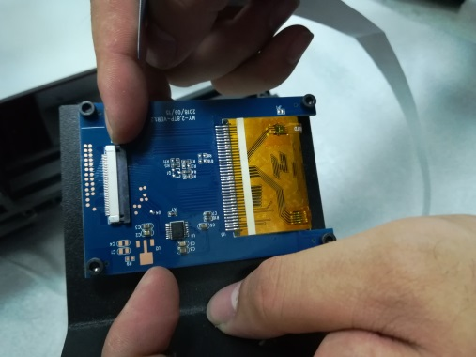
10. Screen wiring
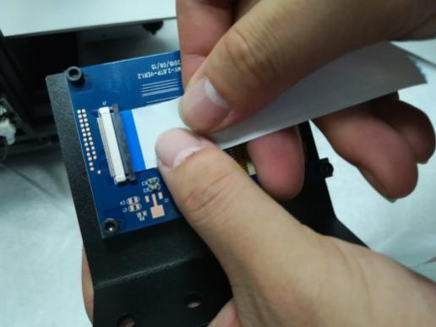

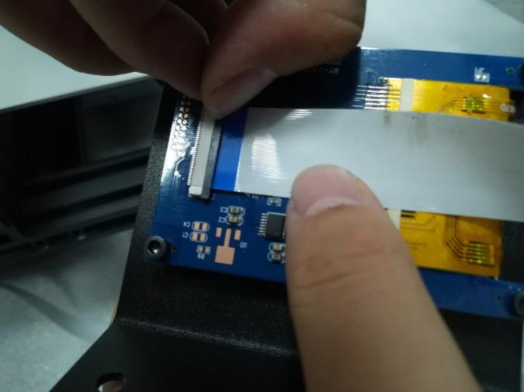
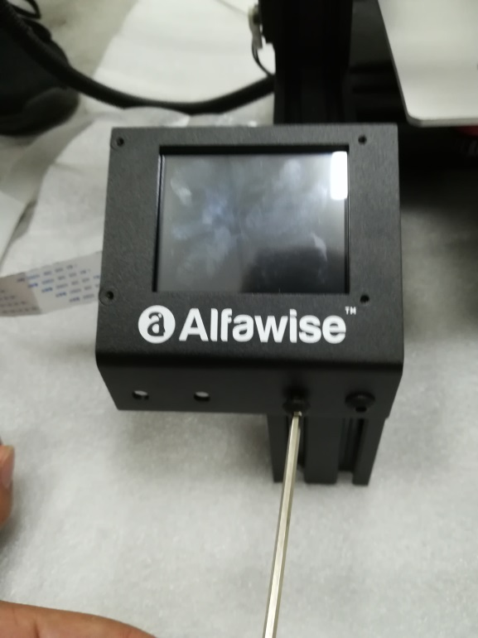

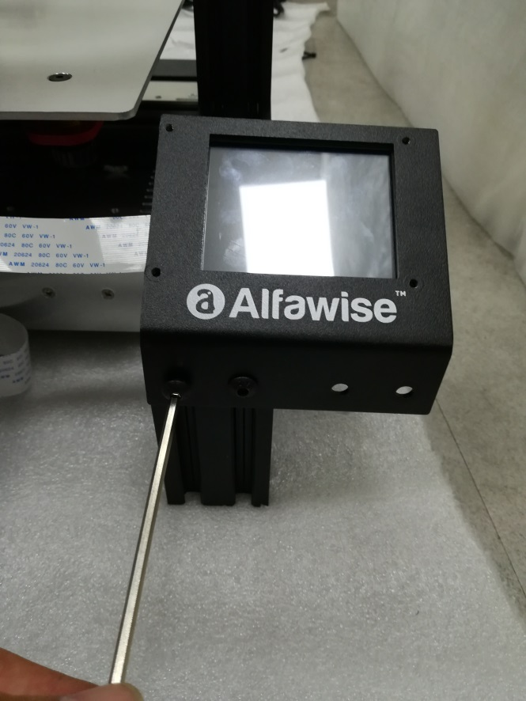

Next to the z-axis motor profile

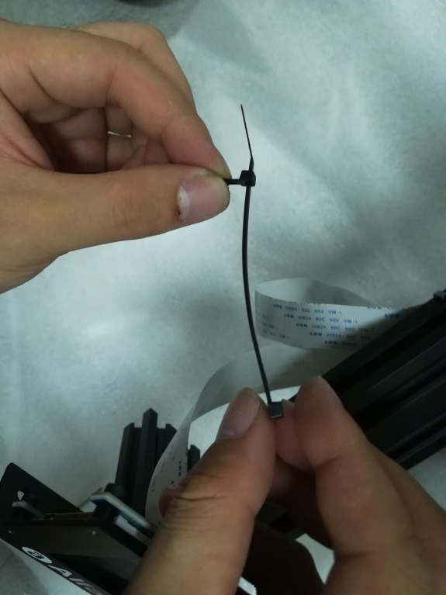

Next to the power profile

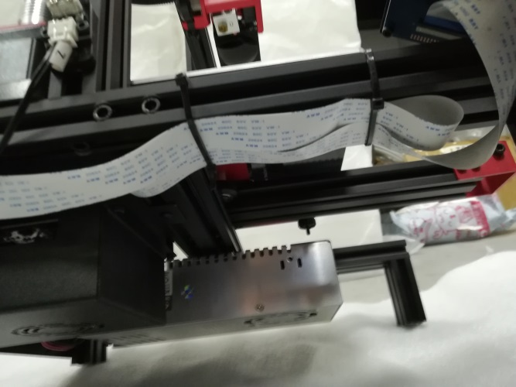

The cable tie can't be too tight

11.Mounting rack and glass
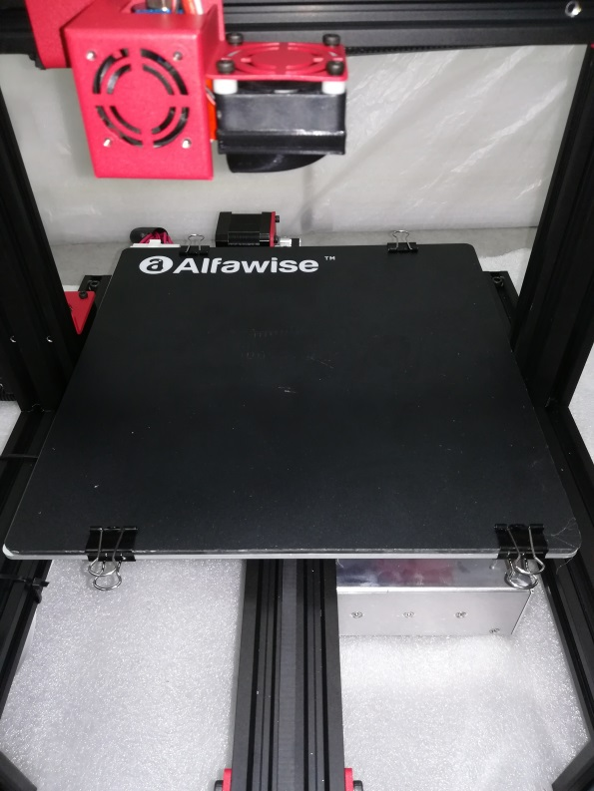
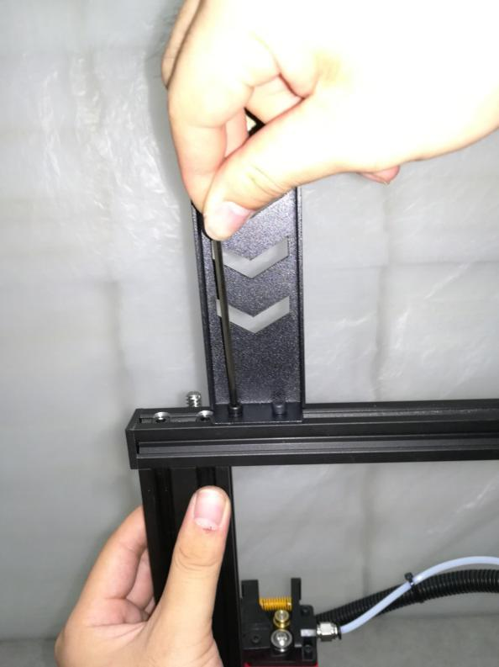

12 .Assembly completed

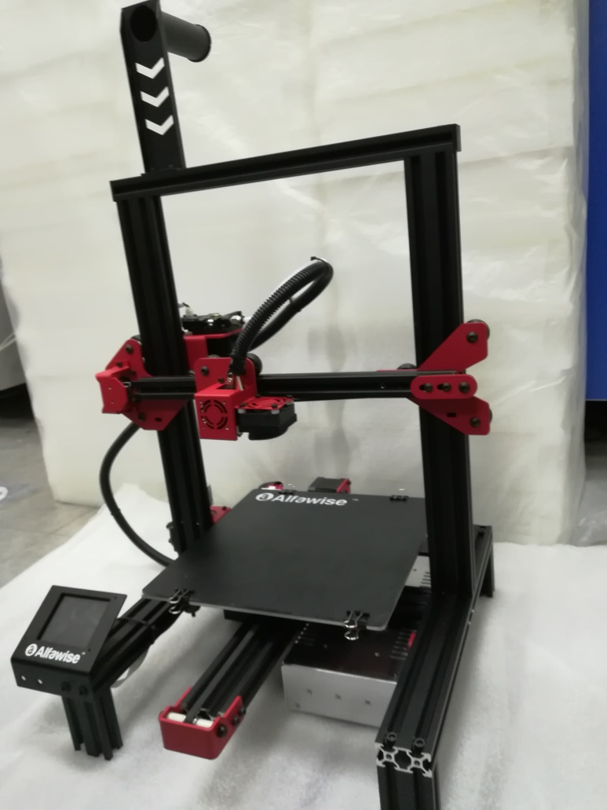

（5） Power regulation
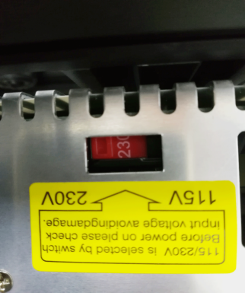
If the access voltage is 220V, please adjust the power supply in the control box to 220V, please be sure to confirm before powering on. Otherwise it will burn the power

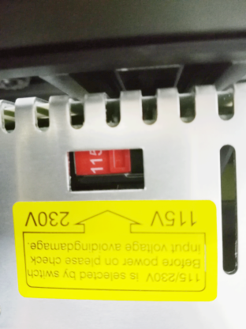
If the access voltage is 110V, please adjust the power supply in the control box to 110V, please be sure to confirm before powering on. Otherwise it will burn the power

（6）leveling method
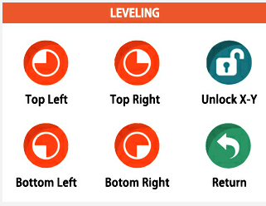
You can manually click the XY zero and Z zero in the Movement interface, then unlock, manually move the hot bed and the nozzle, and then adjust the leveling nut so that the distance from the nozzle to the hot bed is about one A4 paper thickness.。

Turn on the machine, click the levelling button, click the four buttons in turn, the nozzle will move to the corresponding position correspondingly. After waiting to move to the corresponding position, you can manually adjust the hand nut to adjust the distance between the nozzle and the hot bed to approximately one A4. Thicken the paper, tighten the screw [tighten counterclockwise], and increase the distance between the heating plate and the nozzle. Loosen the screw [screw in the clockwise direction] and the heating plate will be close to the nozzle. Adjust the other three points in turn to complete the leveling.
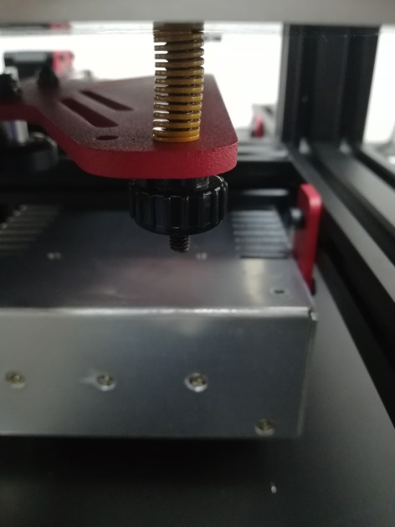

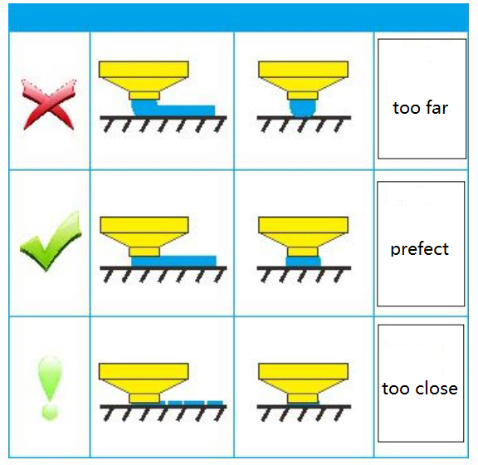

B． Machine operation

（1）Machine control
±X.±Y.±Z（move）

X.Y.Z（home）
±X.±Y.±Z（正负移动）
Move Head

Motor unlock

Moving distance adjustment
Return

Nozzle temperature
printing speed
Start printing
喷嘴温度

Discharge flow
Page flip
Files

distance
Pause printing
暂停打印
Return

Hotbed temperature
Parameter
Print interface

speed of fan
Stop printing
Nozzle temperature

U30
more
Extrude
Hotbed temperature

return
Slow in and out
Automatic feeding and discharging料

Adjustment distance

stop

Top left
Bottom left
Leveling

Top right

Bottom right
Unlock the X.Y motor

Return

Click on the file to enter

More
Refresh
Return

Save

Page flip

Power failure recovery
Recovery

返回

（2）Main interface
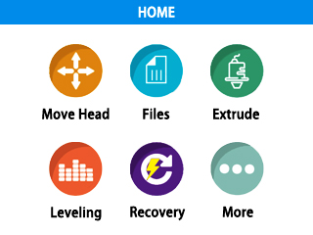
More parameter adjustment
Power failure recovery
Auxiliary leveling function, which can be automatically moved to the corresponding position for easy leveling.
Controls the temperature of the nozzle and the heating platform, and controls the entry or exit of the material.
Open the print file and print interface.
Controls the movement of the X, Y, and Z coordinates, whether the motor is locked, the moving distance of the nozzle, and the amount of ejection.

C． Cura installation and operation software

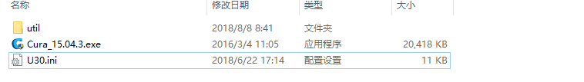

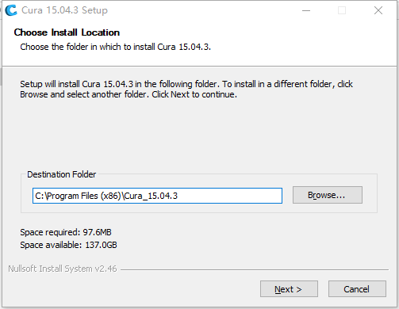
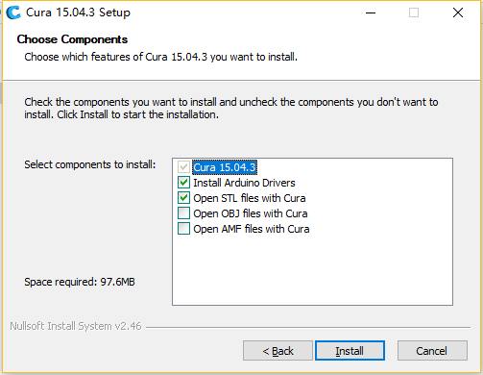
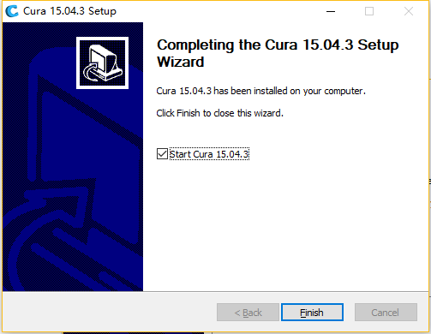
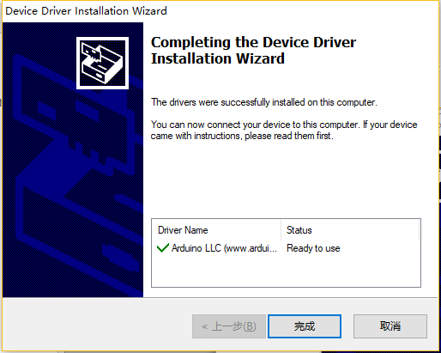
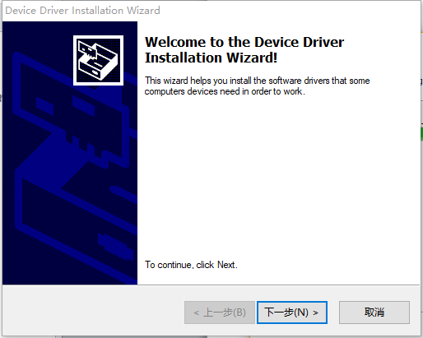
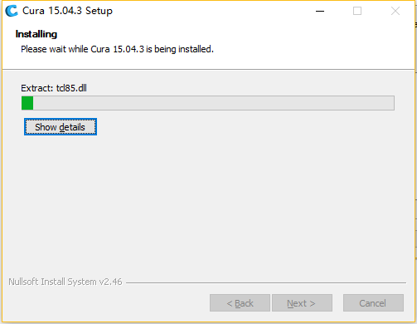
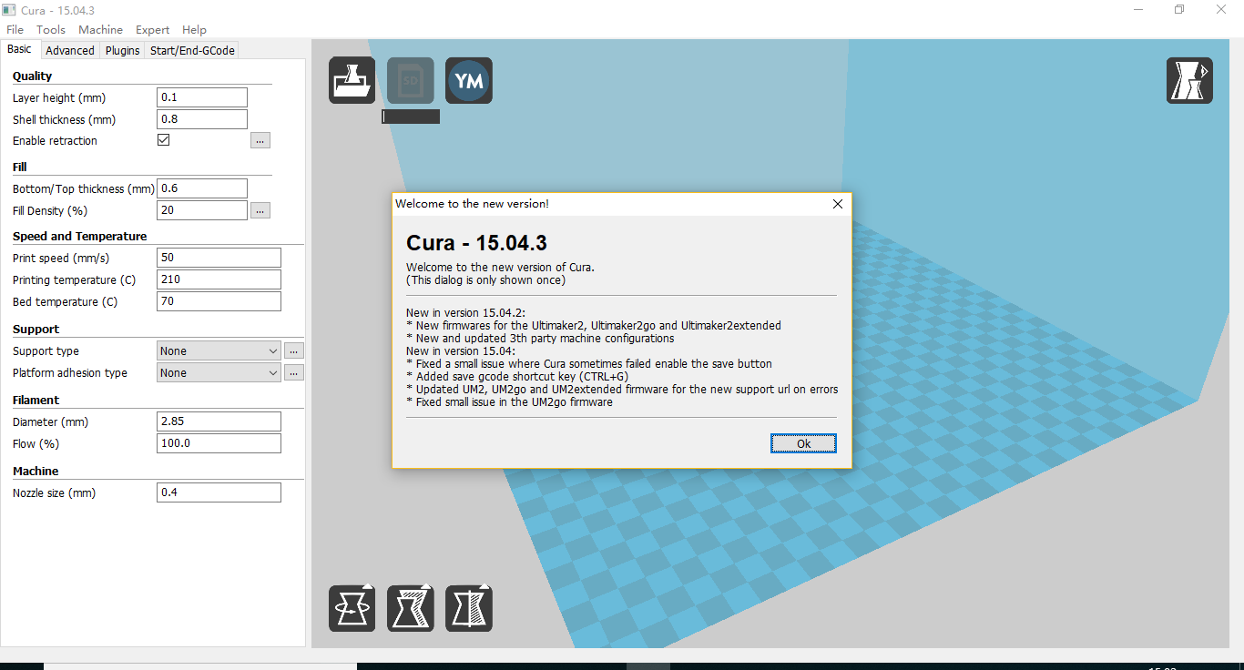
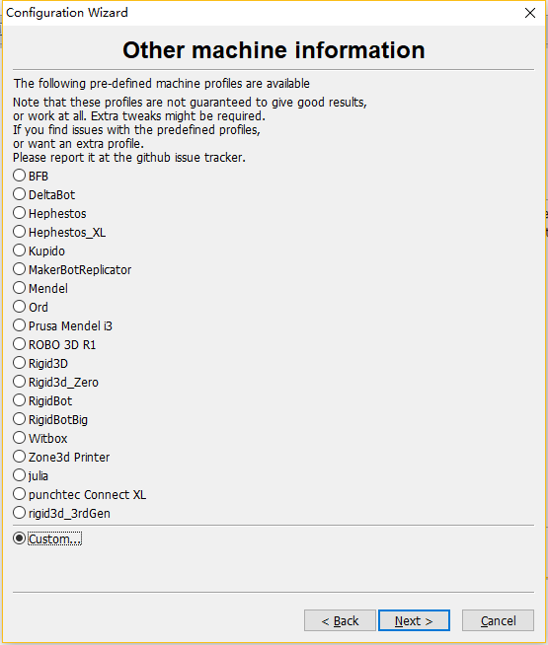
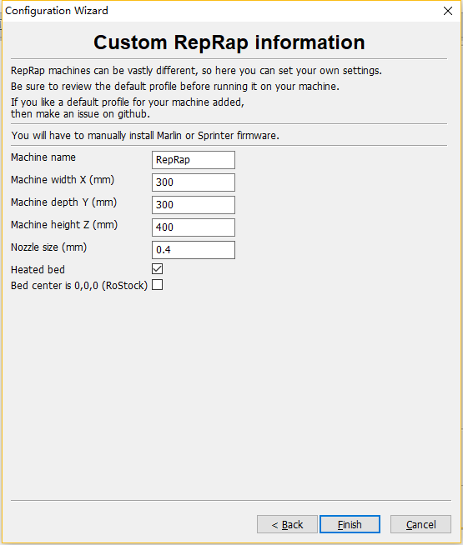
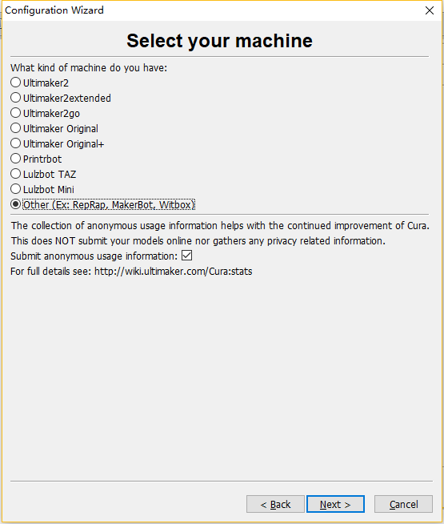
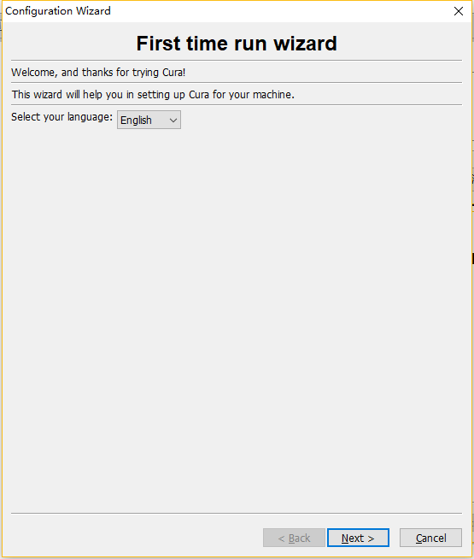
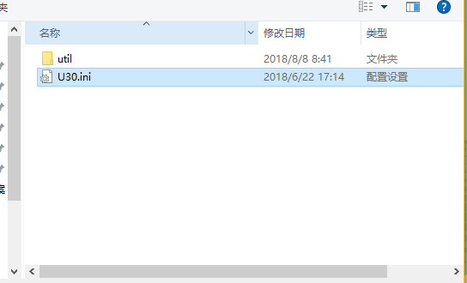
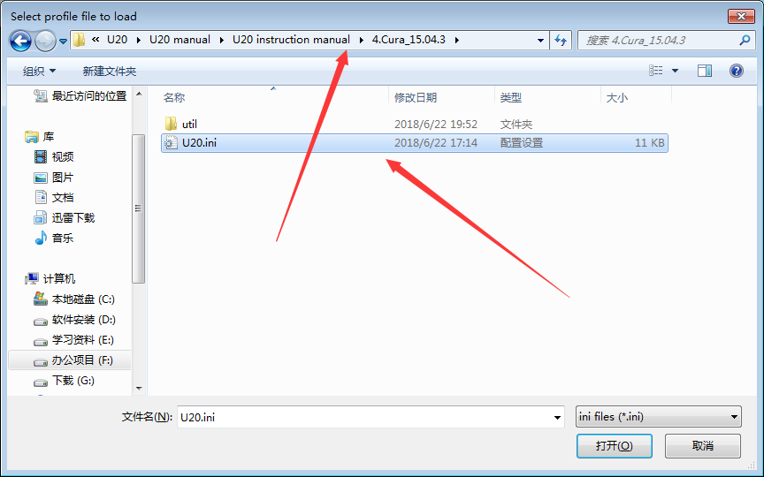
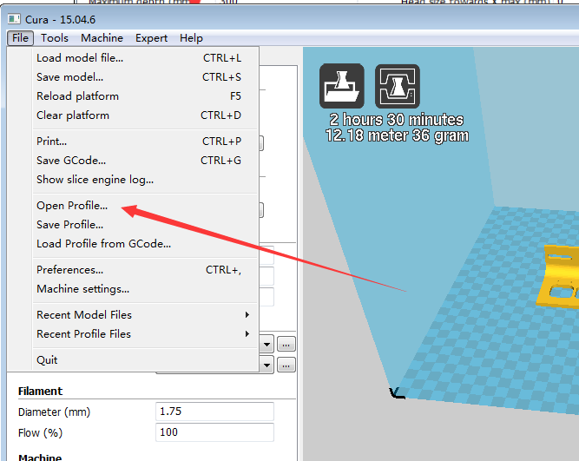
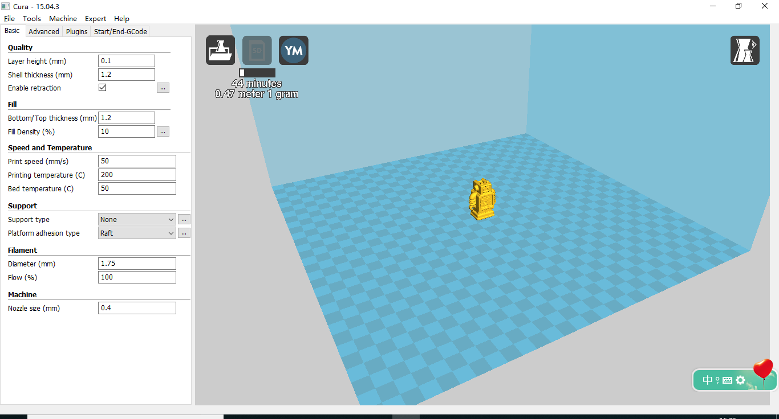

（1） Slice software offline printing instructions
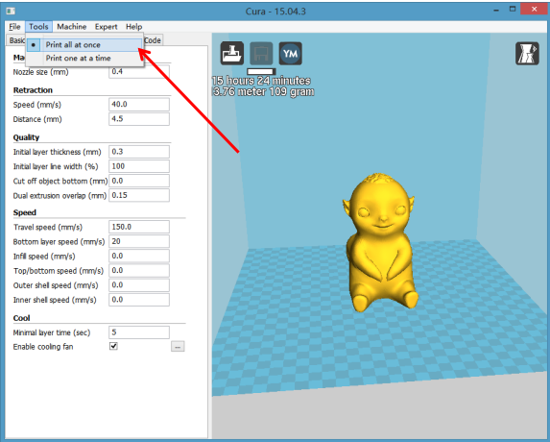
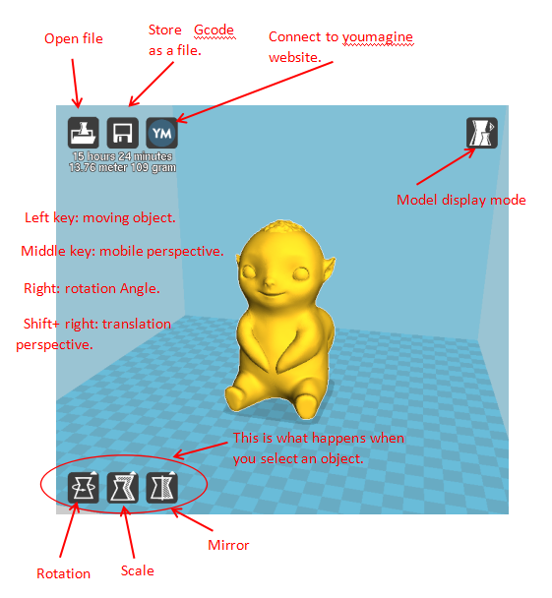
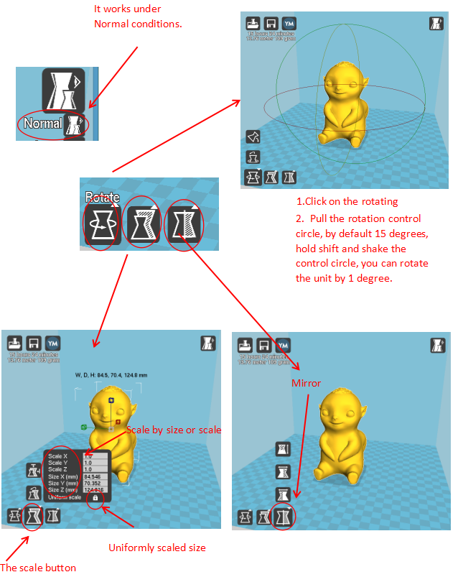

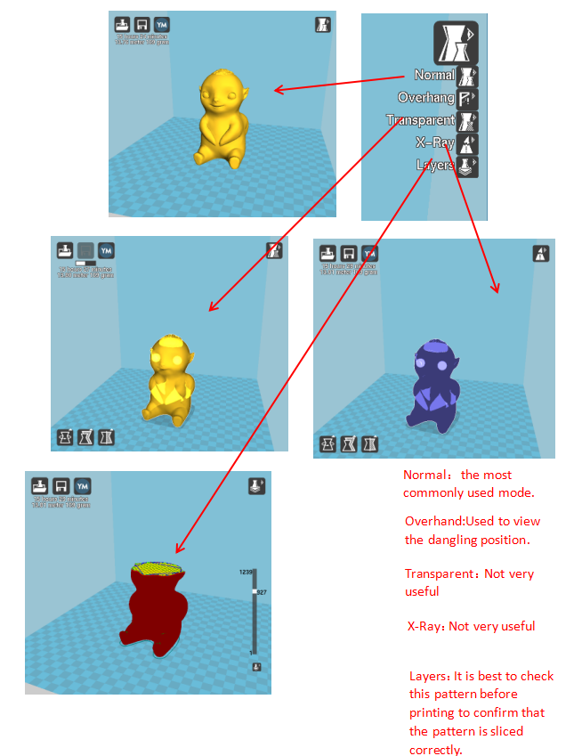
By "File" > Save "<filename>.gcode" (filename is a custom file name, the file name should not be too long). The file name must be English or numeric. It cannot be named as Chinese or special characters. The file must be saved on the SD card. Under the root directory. Save the sliced file to the SD card, insert it into the card slot, turn on the power, and print the steps. Select “Folder” in the main menu of the display, then select the “filename.gcode” file you just saved, and confirm the warm-up. And print

（2）Software parameter setting
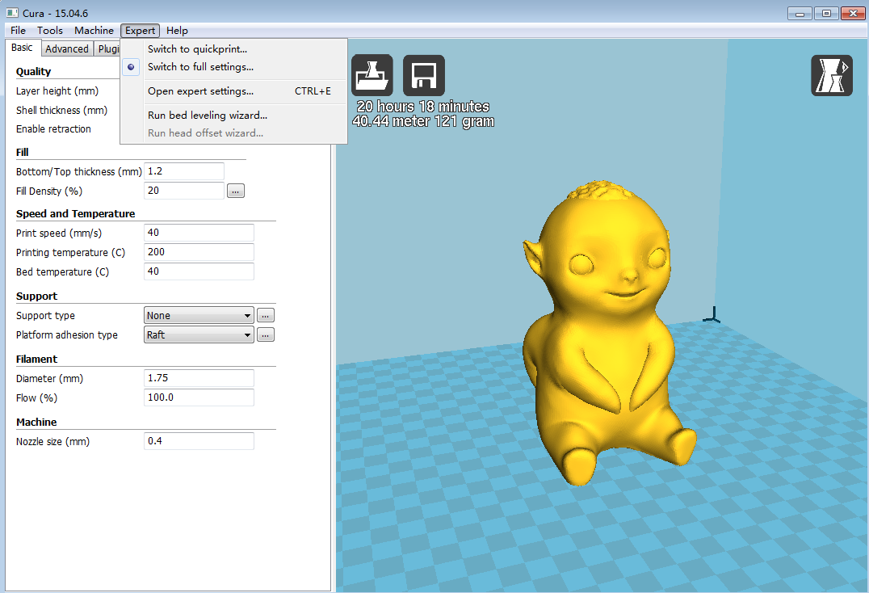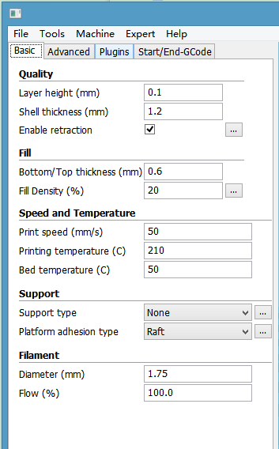
Layer thickness：0.1~0.4mm available. 0.1mm high precision but long printing time, 0.4mm low precision but printing time is too short, in general select 0.2mm.
Shell thickness: 0.4mm is very thin, in general select 1.2mm,that will increase printing time.
Enable retraction: To prevent the wire from leaking when printing quickly, otherwise it will affect the appearance.
Bottom/Top thickness: In order to make the top layer print more perfect and flat bottom layer.
Fill density: If the intensity is not high, select 20%. If the intensity is high, increase it and the printing time also will increase.
Print speed: Generally set 30-100, he print speed is higher and the precision is lower.
Printing temperature: Depends on the filament, generally select 190 ~ 210 degrees.
Support type: Include half-support and full support. In general the model with suspended structure needs to set support, but surface will be rough after removing support.
Platform adhesion type: "None" means do not set any support, "Brim" increases the bottom area. "Raft" base makes the model more adherent. To make the model better adhere to the base, add a base or edge. But best to increase a base and a edge relative to the small bottom area.
Diameter: 1.75mm
Flow: 100%
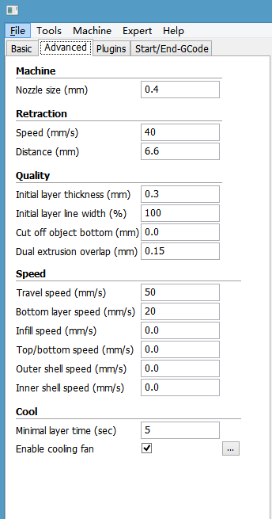
Nozzle size: 0.4mm.
Retraction Speed: The speed of retraction when printing.
Retraction distance: The length of material retraction, generally select 4.5~8mm.
Initial layer thickness: The first layer thickness of printing. Select default option.
Initial layer line width: 100% will be thicker and denser, Select default option.
Cut off object bottom: The length of cutting off the bottom of model.
Dual extrusion overlap: 0.15mm. Select default option.
Travel speed: The moving speed when nozzle does not extrude filament.
Bottom layer speed: The speed of printing the first layer. Setting a slower speed to make object better attached to base plate.
Infill speed, Top / bottom speed, Outer shell speed, Inner Shell speed: Select default option.
Minimal layer time: Select default option.
Enable cooling fan: To cool the temperature of nozzle.

D． Operation for online printing
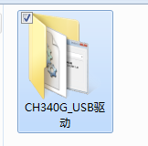
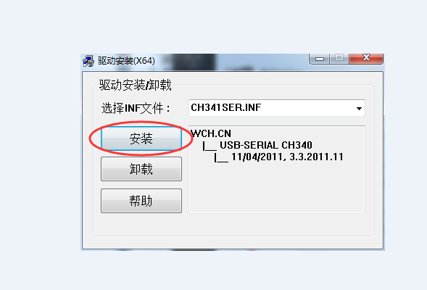
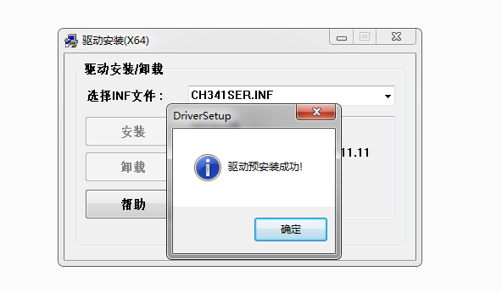
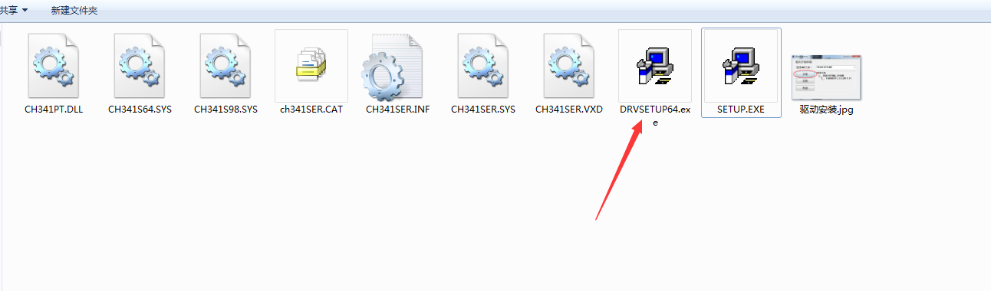
1. Power on the printer, connect USB to a computer, the driver will be installed automatically. If it doesn't install automatically, find the driver under the driver folder and install it manually.
2. Ctrl + "," opens the "Preferences" dialog.
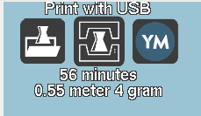
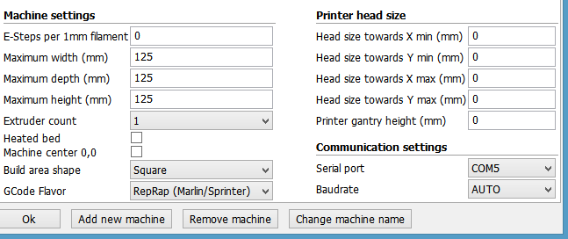
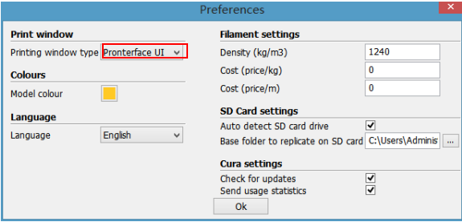
Status shows that the connection has been successfully connected
Select the corresponding serial port (different computer serial ports may be different, generally choose the larger one), the baud rate is "AUTO", click "OK".
3. Click on the menu "Model" "" Model Settings" to open
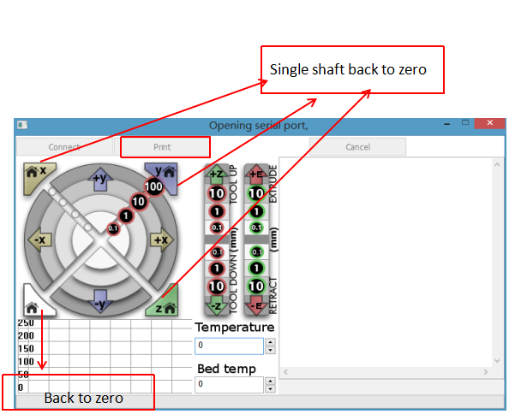
We can click on the gray circle on the window to control the motion of the XYZE axis, respectively, 0.1, 10, 100 means the amount of each movement. The G-code control can be entered in the lower right corner text box. Do not use it if you don't understand it. Click “Print” to start printing. Please be careful during printing to avoid printing failure.
2.After loading a file, click the status icon above or "Ctrl+P" to start printing, and the print window will pop up.

E． Resume printing and filament run-out detection function

（1）Power outage recovery

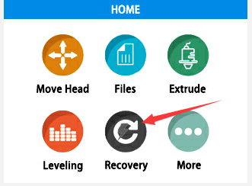
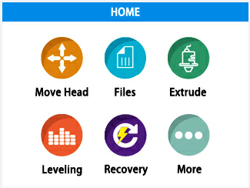
（2）Filament run-out detection
When printing for a period of time and the height of the print exceeds 0.5mm, the power-off icon will be displayed. At this time, the power is turned back on, and the icon can be clicked. After waiting for the temperature to rise, normal printing can be resumed.
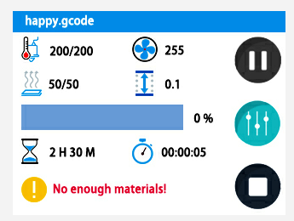
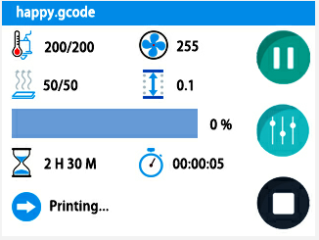
At this point, pull the Teflon tube out of the extruder end, remove the material, refill the consumables to the nozzle, and click the Recovery button to resume printing.

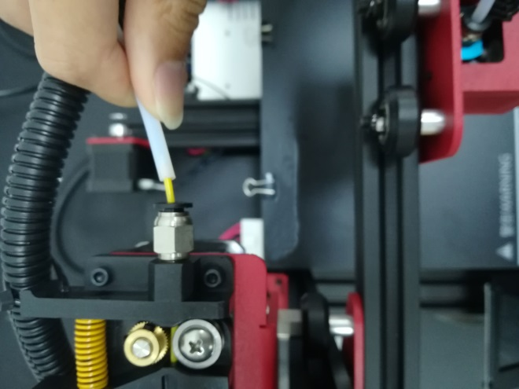
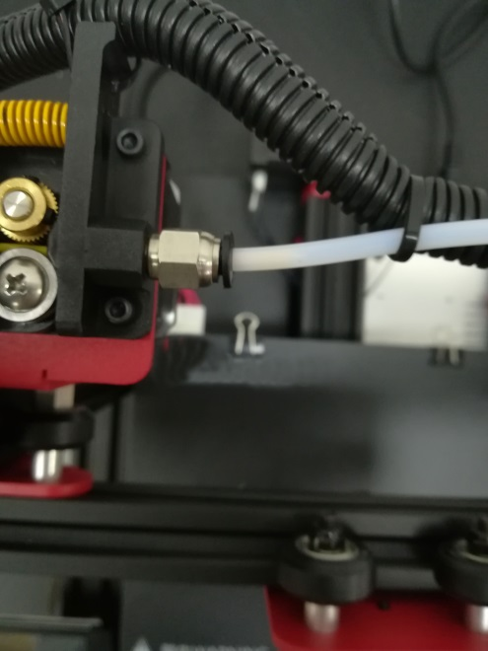

F． FAQ manual

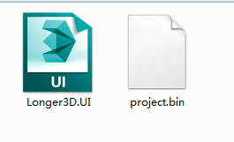
Question1: How to update the firmware?
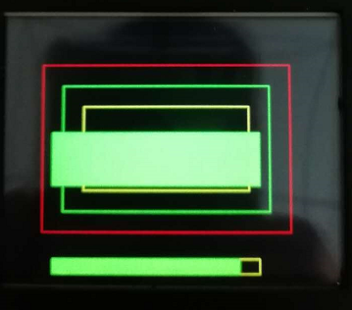
1. Copy these two files to the SD card

2. Then restart the machine and wait for the machine progress bar to complete before the firmware is refreshed.
3. Then the user needs to delete the two files in the SD card to be used normally, otherwise the firmware will be refreshed every time the phone is turned on

Question 2:What if the filament does not discharge from the machine?
1. After the machine nozzle is heated, the consumables are normally fed into the feeding mechanism by hand, and then passed through the Teflon tube to enter the nozzle.
2. When it is found that the gear of the feeding mechanism emits a "beep" sound, it can first check whether the consumables are wound, causing the extrusion mechanism to pull the material.
3 If this is not the reason, raise the machine nozzle and use the 0.4mm needle in the toolbox to insert it from below the copper nozzle and rotate while inserting.
4. Under normal circumstances, this needle can be used to open the copper nozzle, so that the feed is smooth. The reason for this blocking is generally that there are impurities in the consumables, which leads to plugging.

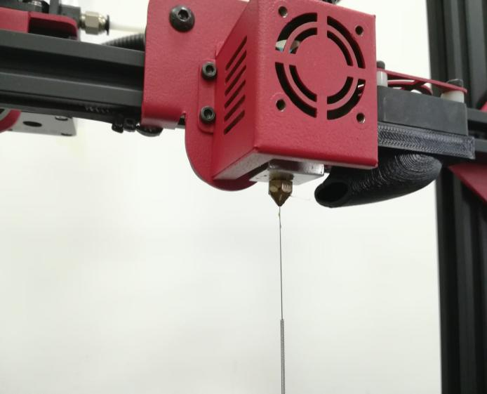

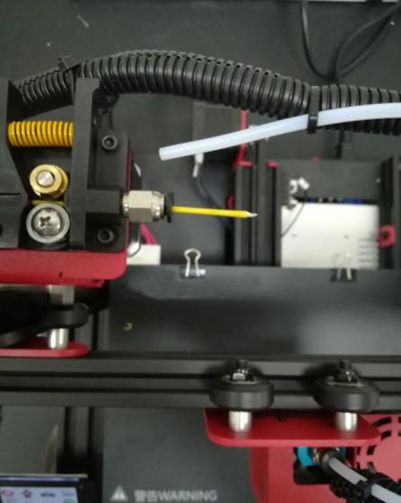
Question 3: When the machine returns the filament, it can't be returned. What should I do when stuck in the pneumatic joint?
1. Before returning the material, please heat the nozzle first, and then withdraw the consumables as soon as possible. If you can't pump it, you can re-feed the material with the advanced material, and melt the extruded block formed at the end of the consumable in the nozzle.

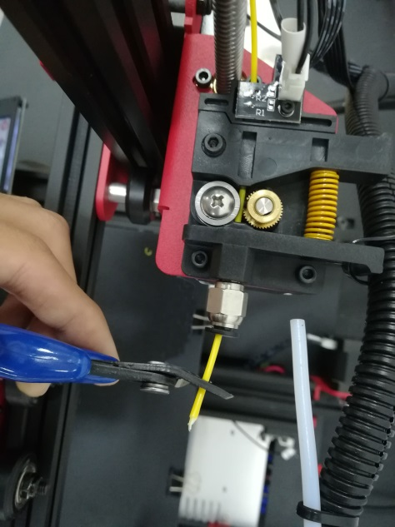

2. When withdrawing the consumables, before the end of the consumables reaches the pneumatic joint, we will usually pull the Teflon directly from the Teflon and cut the end of the consumables.

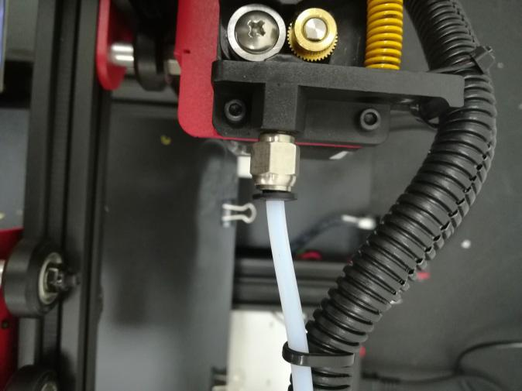

3. Because the end of the consumables in the nozzle will be deformed by heat, if the end deformed consumables are directly pulled out, it may be stuck to the pneumatic joint or the limit switch for damage detection. (The limit switch for the broken material detection is single. Towards).

Question 4: What should I do if I cannot resume printing after power shutdown?
If the power is suddenly turned off when the part is first printed, the machine will not save the print data. Unless the height of the print exceeds 0.5mm, the power failure will be supported. If the height is less than 0.5mm, it is recommended to reprint directly.

Question 5: When the machine is leveling, the nozzle moves to the left, it can be leveled normally. When the nozzle moves to the right, it is found that the distance between the nozzle and the heated bed are very far or very close. If the spring is adjusted to the extreme position, it still cannot be leveled. What should I do?

If this happens, the X-axis beam is generally loose. At this time, the hex socket on the right side of the machine can be adjusted with a wrench to adjust the tightness.

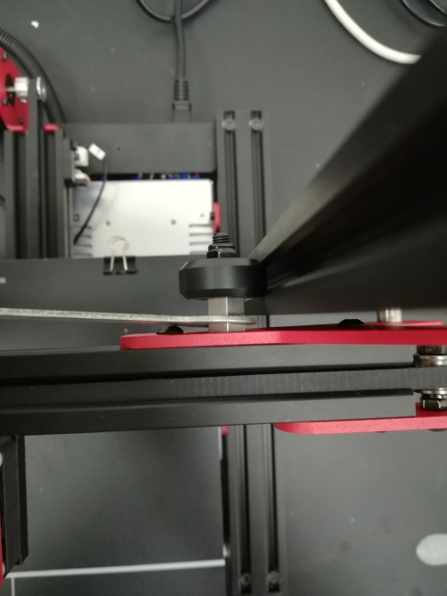
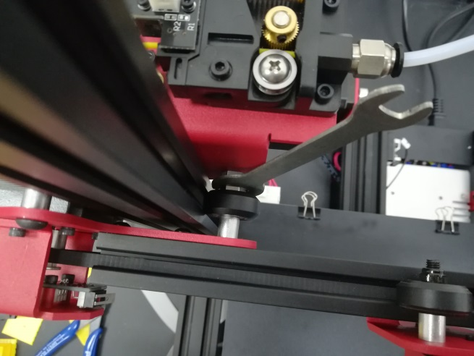

Question 6:
After the machine heats up, the filament is discharged normally. However, when the printing is performed for the first time, the curling occurs on the platform. After printing several layers, the filaments get out of the platform. What can I do

1. After the user gets the 3D printer, if the leveling is found to be curled on the first layer of silk, it feels like it is gently falling on the platform. It can be judged that the leveling is not adjusted, and the nozzle is too high from the hot bed. ,
2. At this point we need to re-level, the quality of the leveling can largely determine the success rate of the part printing.
3. In addition, in order to ensure good contact between the model and the platform, we can set the larger plane of the model face down when slicing, and can also be set in the slicing software to add Raft to the model, which can make the model stick to the platform. Firm.

